DEPARTMENT OF BIOLOGICAL, CHEMICAL, AND PHYSICAL SCIENCE

ILLINOIS INSTITUTE OF TECHNOLOGY

PHYSICS 123

Circular Motion

**Lab 10**

Markiyan Varhola

A20324717

Date of Experiment: Nov. 5, 2015

Due Date: Nov. 12, 2015

Lab Section: 03

Lab Partner: Bhav Bhalla

TA: Shokoufeh Asalzadeh

**Statement of Objective**

The object of this lab was to devise an experiment that would allow for the verification of the principle that states that the accelerating force is proportional to the square of the angular velocity of rotation, and not other variables.

**Theory**

When an object moves in a circle, certain principles of two dimensional motion change. If the radius and the speed of the object are held constant when it is rotating about an axis, the object is still experiencing acceleration since the direction of the velocity is constantly changing.

*Figure 1: A particle moving at constant speed in a circular path.*

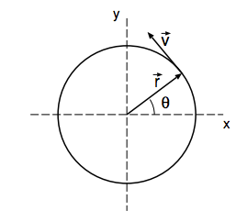

From this diagram, the velocity vector of the object is pointing perpendicular to the direction of the position vector. The acceleration is therefore pointed toward the center of the circular path that the object is taking.

Because the moving body is accelerating toward the center, there is a force in that direction that maintains the acceleration. The force is therefore derived from the following equation:

*Equation 1: centripetal acceleration and force.*

$F=ma=mω^{2}r_{0}=m\frac{v^{2}}{r_{0}}$

**Equipment List**

* Bob
* Spring
* Balancing Mass
* Rotating Platform
* Ruler
* String
* **Safety Goggles**
* Data Studio Software

**Procedure**

On a rotating platform, several masses were suspended from the spring and the extension of the spring was measured. Next, a voltage was applied to the rotating platform until the marker on the spring lined up with a measured marking on the rod that was holding it up. After that was achieved, the angular velocity was recorded, as well as the displacement of the original mass in terms of radius. For the second experiment, additional mass was added, to show that the relationship between the radius and the force is proportional.

**Data**

*table 1: spring coefficient*

|  |  |  |  |
| --- | --- | --- | --- |
| **m** | **x** | **k** | **k (avg)** |
| 0.025 | 0.011 | 22.3 | 25.17 |
| 0.045 | 0.017 | 25.97 |  |
| 0.05 | 0.018 | 27.25 |  |

Experiment 1

*table 2: force and angular velocity*

|  |  |  |  |  |  |
| --- | --- | --- | --- | --- | --- |
| **x** | **w (angular velocity)** | **r** | **F** | **w^2** | **F/(W^2)** |
| 0.005 | 2.94 | 0.11 | 0.95 | 8.64 | 0.11 |
| 0.01 | 3.7 | 0.12 | 1.643 | 13.69 | 0.12 |
| 0.02 | 4.62 | 0.13 | 2.774 | 21.34 | 0.13 |
| 0.03 | 5.6 | 0.15 | 4.704 | 31.36 | 0.15 |
| 0.04 | 6.45 | 0.17 | 7.072 | 41.6 | 0.17 |

Experiment 2

*table 3: force and angular velocity*

|  |  |  |  |  |  |  |
| --- | --- | --- | --- | --- | --- | --- |
| ***w*** | ***x*** | ***m*** | ***r*** | ***F*** | ***w^2*** | ***r/F*** |
| *2.6* | *0.005* | *0.005* | *0.105* | *0.713* | *6.76* | *0.15* |
| *2.6* | *0.01* | *0.015* | *0.11* | *0.755* | *6.76* | *0.15* |
| *2.6* | *0.015* | *0.025* | *0.12* | *0.831* | *6.76* | *0.14* |
| *2.6* | *0.02* | *0.035* | *0.125* | *0.875* | *6.76* | *0.14* |

**Analysis of Data**

By using the set of equations, the value for the force and the square of angular acceleration was calculated.

*Graph 1: Angular Acceleration vs Force*

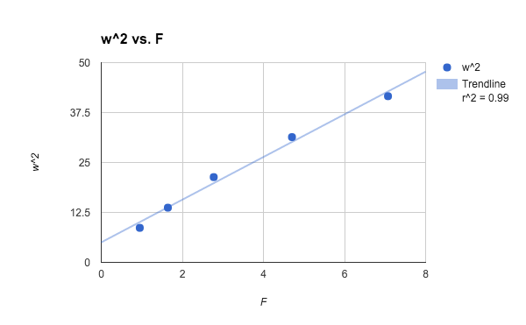

The relationship between the square of the angular acceleration is linearly proportional to the accelerating force.

*Graph 2: Linear relationship between the force and the radius of rotation.*

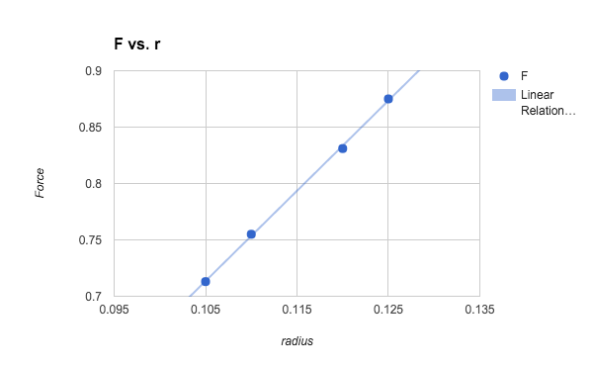

The relationship between the square of the acceleration force is linearly proportional to the radius of rotation.

**Discussion of Results**

Part 1:

In part 1, the values for the experiment were very accurate and netted a result that verified the laws of circular motion. An R value of .99 showed that a linear trendline best described the correlation between the two values, and therefore shows their proportional relationship.

Part 2:

In part 2, the values for the experiment were very accurate and netted a result that verified the laws of circular motion. An R value of .99 showed that a linear trendline best described the correlation between the two values, and therefore shows their proportional relationship.

There were several factors that could have caused errors in measurements, such as:

* Friction
* Accuracy of measurements
* Slight variations in the actual values vs the measured values.

**Conclusions**

The projectile motion laws meant to be tested by this experiment were supported by actual data, which was very accurate and described the relationships very well. Therefore, the experiment was done correctly, albeit with small sources of error.

**References**

1. Physics 123 lab manual, Experiment 10. http://science.iit.edu/sites/science/files/elements/phy/pdfs/2013_lab_123_10.pdf